САНКТ-ПЕТЕРБУРГСКИЙ ПОЛИТЕХНИЧЕСКИЙ УНИВЕРСИТЕТ ПЕТРА ВЕЛИКОГО

ИНСТИТУТ КОМПЬЮТЕРНЫХ НАУК И ТЕХНОЛОГИЙ

Высшая школа программной инженерии

Направление: «Информатика и вычислительная техника»

Профиль: «Распределённые информационные системы»

Специальность: 02.03.20 «Фундаментальная информатика и информационные технологии»

 Группа 3530202/90202 6-й семестр (весна 2021)

**Отчёт о курсовой работе**

по дисциплине «**Семейства протоколов компьютерных сетей**»

(на английском языке «***Network Protocol Families***»)

на тему

**«**PPPoA protocols (PPP over ATM)**»**

«PPPoA протоколы (PPP over ATM)»

**Выполнила:**

студент группы 3530202/90202 Потапова А.М.

**Руководитель:**

 к.ф.м-н. доц. Глебовский А.Ю.

*“01” апреля 2022 г.*

- Санкт-Петербург -

2022 г.

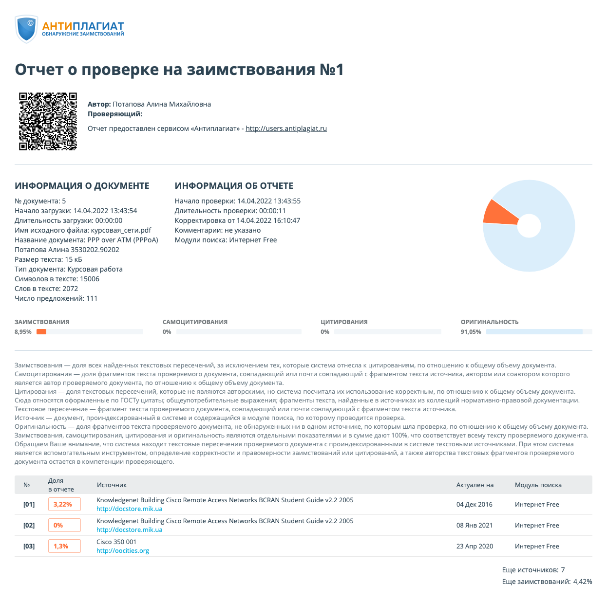

**Table of Contents**

Abstract 4

Link layer protocols 5

DSL modem 5

ADSL (Asymmetric Digital Subscriber Loop) 5

ATM (Asynchronous Transfer Mode) 6

AAL5 (ATM Adaptation Layer 5) 7

PPP 8

PPPoA (PPP over ATM) 9

Operational Description of PPPoA Architecture 10

PPPoA vs PPPoE 11

References 12

# **Abstract**

The Point-to-Point Asynchronous Transfer Mode (PPPoA) protocol is based on two standards: PPP and ATM. It is an end-to-end asymmetric digital subscriber line (ADSL) architecture. The IP packets are transmitted from the PC over Ethernet to the DSL modem called an ADSL transceiver unit remote (ATU-R). The ATU-R adds PPP to IP packets and forwards them to Digital Subscriber Line Multiple Access (DSLAM) via ATM. This technology is becoming more and more popular among DSL providers. It offers standard PPP features such as authentication, encryption, and compression.

Point-to-Point Asynchronous Transfer Mode (PPPoA) is specified in RFC 2364.

In this work, I will review the concepts related to PPPoA and compare it with the equally well-known PPPoE.

**Keywords**

DSL, ADSL, ATM, AAL5, IP, PPP, PPPoE, PPPoA, ISP, OSI, RFC 2364, VPI, VCI, Ethernet

# **Link layer protocols**

The lower levels of communication protocols form a channel layer that defines the basic packet data transfer technology between subscribers within the same network. Just as a traditional communication system uses various methods of delivering letters in paper packages of various formats and sizes, computer networks can use different basic technologies for delivering data packets, depending on specific conditions.

Before describing the protocols, let's look at the concept of a DSL modem and ADSL modem technology.

# **DSL modem**

DSL (digital subscriber line) is a technology that provides high-speed data transmission over conventional twisted-pair telephone lines. In short, a router with a DSL modem converts a DSL line into an Ethernet connection and creates a wireless network.

# **ADSL (Asymmetric Digital Subscriber Loop)**

Over the last few years, the growth in the volume of information transmission has led to a lack of bandwidth for access channels to existing networks. The most promising technology today is ADSL.

This modem technology turns standard analog subscriber telephone lines into high-speed access lines. Since this technology is asymmetric, the data transfer rate from the network to the user is much higher than the data transfer rate from the user to the network. This asymmetry, combined with the "always connected" state (where there is no need to dial a phone number each time and wait for a connection to be established), makes ADSL technology ideal for providing access to the Internet, access to local area networks (LANs), etc. When organizing such connections, users usually receive much more information than they transmit.

ADSL technology allows you to transfer information to the subscriber at a speed of up to 6 Mbps. In the opposite direction, speeds up to 640 Kbps are used. Let’s explore in more detail how packets are carried over ADSL links.

# **ATM (Asynchronous Transfer Mode)**

Asynchronous Transfer Mode was developed in the early 1990's and launched with incredible media hype. ATM corresponds to the physical, channel and, in part, network layers of the OSI (Open Systems Interconnection) model. Although ATM has some of the characteristics of a packet-switched technology, it is still a circuit-switched technology. At the same time, it retains the advantages of both technologies: low delays as for circuit switching, and a high percentage of resource utilization as for packet-switched technology.

The ATM protocol is engaged in cell transmission via switches when a virtual connection is established and configured, i.e., based on ready-made port switching tables. The ATM protocol toggles by virtual connection number, which in ATM technology is split into two parts - the Virtual Path Identifier (VPI) and the Virtual Circuit Identifier (VCI). In addition to this main task, the ATM protocol performs several functions to monitor compliance with the traffic contract by the network user, mark offending cells, discard offending cells when the network is congested, and control the flow of cells to improve network performance (of course, subject to the conditions of the traffic contract for all virtual connections).

To send data over an ATM network, it must be converted to a sequence of cells. This mapping is performed on the ATM adapter layer during the reassembly and segmentation process. There are different levels of accommodation in various services.

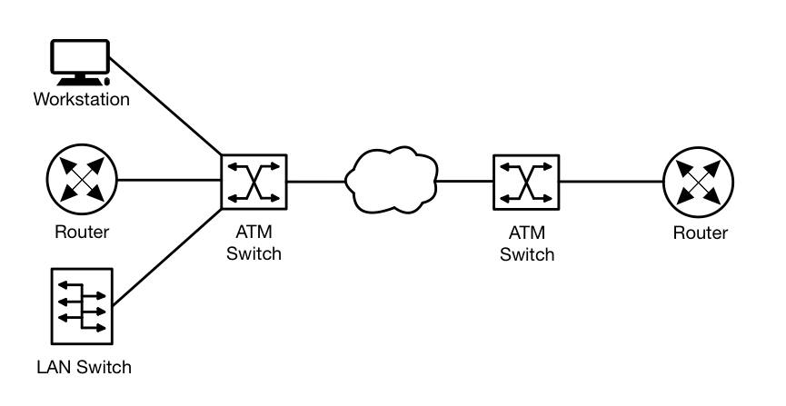

*Figure 1. Asynchronous Transfer Mode network [9]*

# **AAL5 (ATM Adaptation Layer 5)**

In Asynchronous Transfer Mode (ATM) networks, the ATM Adaptation Layer (AAL) provides the means for non-ATM networks to connect to an ATM network and use its services. The most widely used is ATM Adaptation Layer 5 (AAL 5).

AAL 5 was originally called Simple and Efficient Adaptation Layer (SEAL). The main features of AAL 5 are segmentation and reassembly. It receives higher layer packets and segments them into 48-byte ATM cells before being transmitted over the ATM network. On the receiving side, it reassembles the cells into higher layer packets.

Networks using AAL5:

* Internet Protocol (IP) over ATM
* Ethernet over ATM
* Switched Multimegabit Data Service (SMDS)
* LAN Emulation (LANE)

The AAL5 payload encapsulates the PPP protocol and the PPP data. A padding is added and then the AAL 5 trailer is appended. The AAL 5 trailer may contain several fields, the common among which are the length of the payload and the error detection code, typically CRC (Cyclic Redundancy Check). The following diagram (Fig. 2) shows a PPPoA frame, i.e. a PPP frame encapsulated in an AAL 5 frame.

*Figure 2. AAL5 frame carrying PPP data [1]*

# **PPP**

Point-to-Point Protocol (PPP) is a TCP/IP protocol used to connect two computer systems. Internet systems can communicate with each other over telephone lines using point-to-point protocol, or PPP. This protocol involves the physical connection of two systems over a telephone line. For example, a PPP connection between a server in a branch office and a server in the central office allows data to be transferred from one system to another. Also, PPP allows network software from different vendors to interoperate. In addition, with its help, several network protocols can use one communication line.

PPP provides a method for transmitting a datagram over a point-to-point serial link and contains three main features:

1) Datagram encapsulation method via serial links. PPP uses the High-Level Link Control (HDLC) protocol as the basis for datagram encapsulation over point-to-point links.

2) Link Control Protocol (LCP) for establishing, configuring, and testing a data link connection.

3) Network Control Protocol (NCP) suite for establishing and configuring various network layer protocols. PPP is designed to use multiple network layer protocols at the same time.

Now that we have described ATM and PPP, we can simply describe how PPP uses ATM in the case of ADSL.

# **PPPoA (PPP over ATM)**

PPPoA (Point-to-point protocol over ATM) is a link layer network protocol for encapsulating PPP frames using AAL5. The protocol offers all the features of PPP, such as authentication, encryption, and data compression. PPPoA was primarily implemented as part of ADSL.

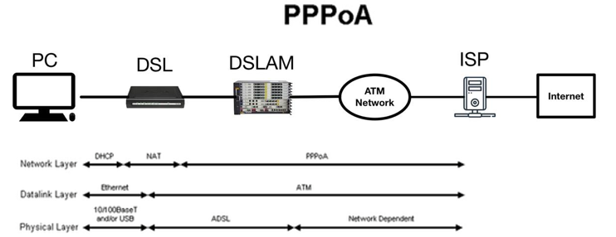

*Figure 3. PPP over ATM [8]*

Some of the advantages of PPP, which inherits PPPoA architecture:

* Based on the PAP (Password Authentication) and CHAP (Handshake Challenge Authentication Protocol) protocols, this protocol implements per-session authentication. Since authentication overcomes a security hole in the bridge architecture, this can be considered the biggest advantage of this protocol.
* Accounting is possible for each session. It means that the service provider can charge the client depending on the session time for different services.
* IP address conservation at the CPE. This means that users behind the same CPE can use the same IP address to access different destinations.
* Troubleshooting individual subscribers. The NSP can easily identify which subscribers are on or off based on active PPP sessions, rather than troubleshooting entire groups as is the case with bridging architecture.
* Optimal use of features on the Service Selection Gateway (SSG).

# **Operational Description of PPPoA Architecture**

The first time the CPE is turned on, it starts sending LCP configuration requests to the aggregation server. This service then sends a configuration request to the virtual access interface with configured PVCs. Then comes the acknowledgment of requests, after they have seen each other's requests, and the LCP status is opened.

During the authentication phase, the CPE sends a request to the aggregation server. Depending on the configuration, the server either authenticates the user based on the domain name or the username using RADIUS servers or a local database. If the request from the subscriber is <username@domainname> and there is no tunnel to the destination, the aggregation server will try to create one.

After the tunnel is created, the aggregation server will forward PPP requests from the subscriber to the destination. It will authenticate the user and assign an IP address. If the request from the subscriber does not include a domain name, the user is authenticated against the local database.

The user may also be able to select different services if SSG is configured on the aggregation router.

# **PPPoA vs PPPoE**

Both protocols provide ISPs with the ability to deploy broadband access. The use of these protocols provides relative security because it requires the end user to verify or authenticate with the server before accessing the network.

PPPoE and PPPoA are primarily used with Digital Subscriber Line (DSL). Both protocols provide flexibility in billing, which is very beneficial for providers. What's more, network resource usage can be easily monitored, and along with this feature, troubleshooting and managing network usage is less of a problem.

In enterprise packages, PPPoA is usually the protocol of choice. Rumor has it that PPPoA has less overhead compared to PPPoE, so the former is slightly faster than the latter. However, for the end user, the difference in speed is almost negligible.

Modems that support PPPoA use asynchronous transmission mode - which uses very small-fixed length packets, unlike Ethernet which uses relatively large variable length packets - to do what it needs to do.

Let's summarize:

* If PPPoA is used as a connection encapsulation method in an ATM-based network, then it can reduce the overhead slightly (about 0.58%) compared to PPPoE.
* PPPoA avoids the problems that PPPoE suffers from with a smaller MTU than standard Ethernet transmission protocols.
* PPPoA also supports (like PPPoE) encapsulation types based on VC-MUX and LLC.
* While PPPoE is used in most countries, PPPoA (ADSL) is used in the UK, New Zealand, Belgium, France, Denmark, Italy, Austria, Poland, and the Netherlands. In these regions, the supplied ADSL modem/router must support PPPoA.

# **References**

1. Andrew S. Tanenbaum, David J. Wetherall. Chapter 3.5 Example data link protocols / / Computer Networks. - 5th ed. - Pearson , 2011 - p. 933 — ISBN-13: 978-0-13-212695-3
2. Olifer V. G., Olifer N. A. Chapter 6 Global networks. ATM technology / / Computer networks. Principles, technologies, and protocols. - 4th ed. - St. Petersburg: Peter, 2010 - p. 438 — ISBN 978-5-49807-389-7
3. URL: https://www.cisco.com/c/en/us/support/docs/long-reach-ethernet-lre-digital-subscriber-line-xdsl/pppoe-pppoa-ppp-over-ethernet-ppp-over-atm/12914-pppoa-arch.html (resource access date: 02.04.2022)
4. URL: https://www.rfc-editor.org/rfc/rfc2364 (resource access date: 02.04.2022).
5. URL: https://www.tutorialspoint.com/atm-adaptation-layer-5-aal-5 (resource access date: 02.04.2022)
6. URL: https://networkencyclopedia.com/asynchronous-transfer-mode-atm/ (resource access date: 02.04.2022)
7. URL: http://www.differencebetween.net/technology/internet/difference-between-pppoe-and-pppoa/ (resource access date: 02.04.2022)
8. URL: https://www.networxsecurity.org/members-area/glossary/p/pppoa.html (resource access date: 02.04.2022)
9. URL: https://networkencyclopedia.com/asynchronous-transfer-mode-atm/ (resource access date: 02.04.2022)